Programming Languages Research Report

Course: CST 8002-040 Programming Languages Research Proj.
Assignment: Practical Project04
Instructor: Tyler DeLay
Student Name: Qinyu Luo
Student ID: 041137796
Due Date: 11/30
Submitted: 11/26

Evidence of Learning

Business Layer Implementation (DataManager.js)
The multiColumnSort method was added to the DataManager class (lines 130-180 in DataManager.js). This method implements the core sorting logic:
multiColumnSort(sortRules) { if (!sortRules || sortRules.length === 0) { console.log('No sort rules provided'); return this.records; } const sortedRecords = [...this.records]; sortedRecords.sort((a, b) => { for (let rule of sortRules) { const column = rule.column; const order = rule.order; let comparison = 0; if (typeof a[column] === 'string') { comparison = a[column].localeCompare(b[column]); } else { comparison = a[column] - b[column]; } if (order === 'desc') { comparison = -comparison; } if (comparison !== 0) { return comparison; } } return 0; }); return sortedRecords; }
Key features of this implementation:
- Creates a copy of the records array to avoid modifying the original data (immutability principle)
- Iterates through sort rules in priority order
- Handles both string comparison (using localeCompare) and numeric comparison
- Supports ascending and descending sort orders
- Implements cascading sort: if values are equal in the first column, it moves to the next column

Presentation Layer Implementation (UserInterface.js)
The sortRecordsMultiColumn method was added to the UserInterface class (lines 250-340 in UserInterface.js). This method handles user interaction:
async sortRecordsMultiColumn() { const availableColumns = ['identification', 'year', 'transect', 'quadrat', 'name', 'count']; console.log('Available columns to sort by:'); availableColumns.forEach((col, index) => { console.log(` ${index + 1}. ${col}`); }); const sortRules = []; let addMore = true; while (addMore && sortRules.length < availableColumns.length) { const colInput = await this.prompt('Enter column number: '); const colIndex = parseInt(colInput) - 1; if (isNaN(colIndex) || colIndex < 0 || colIndex >= availableColumns.length) { console.log('Invalid column number.'); continue; } const selectedColumn = availableColumns[colIndex]; if (sortRules.some(rule => rule.column === selectedColumn)) { console.log('Column already selected.'); continue; } const orderInput = await this.prompt('(a)scending or (d)escending? '); const order = orderInput.toLowerCase() === 'd' ? 'desc' : 'asc'; sortRules.push({ column: selectedColumn, order }); const continueInput = await this.prompt('Add another column? (y/n): '); addMore = continueInput.toLowerCase() === 'y'; } const sortedRecords = this.dataManager.multiColumnSort(sortRules); // Display sorted results... }
Key features of this implementation:
- Displays available columns to the user with numbered options
- Validates user input for column selection and sort order
- Prevents duplicate column selection
- Allows users to add multiple sort criteria interactively
- Delegates sorting logic to the business layer (DataManager)
- Displays sorted results with proper formatting including programmer name

Program Changes
The multi-column sort feature was integrated into the existing project following the MVC (Model-View-Controller) architecture. The implementation involved modifications to two main files:

1. Business Layer (business/DataManager.js)
Added the multiColumnSort method (lines 130-180):
- This method accepts an array of sort rules as parameters
- Each sort rule contains a column name and sort order (ascending/descending)
- The method creates a copy of the records array to maintain immutability
- Uses JavaScript's Array.sort() with a custom comparator function
- Implements cascading sort logic by iterating through sort rules in order
- Returns the sorted array without modifying the original data

2. Presentation Layer (presentation/UserInterface.js)
Made the following modifications:
- Updated displayMenu() method (line 30): Added menu option 11 for multi-column sort
- Changed exit option from 11 to 12
- Added sortRecordsMultiColumn() method (lines 250-340): Implements user interaction for the sorting feature
- Updated start() method switch statement (line 390): Added case '11' to call sortRecordsMultiColumn()
- Updated case '12' for exit functionality (previously case '11')

Architecture Compliance
The implementation follows the layered architecture pattern established in previous projects:
- Presentation Layer: Handles all user input and output display
- Business Layer: Contains the core sorting logic and data manipulation
- Model Layer: Record.js remains unchanged, providing the data structure
- The separation of concerns ensures that sorting logic is independent of user interface, making the code maintainable and testable

Program Demonstration via Screen Shots

Screenshot 1: Main Menu with New Sort Option
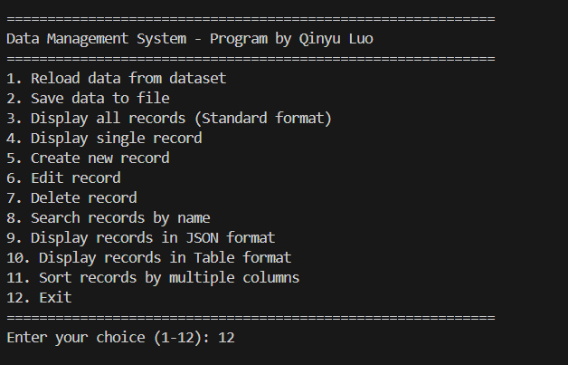
This screenshot shows the updated main menu with the new option 11 for multi-column sorting. The menu displays all available options including the new sorting feature, with the program author's name (Qinyu Luo) prominently displayed at the top.

Screenshot 2: Selecting Sort Columns
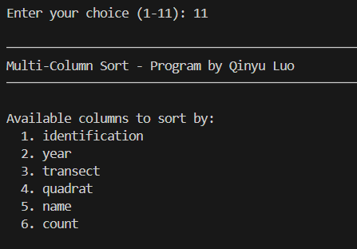
This screenshot demonstrates the user selecting columns for sorting. The available columns are displayed with numbers (1-6), and the user can select which column to sort by first. The interface shows the prompt for column selection and sort order (ascending or descending).

Screenshot 3: Adding Multiple Sort Criteria
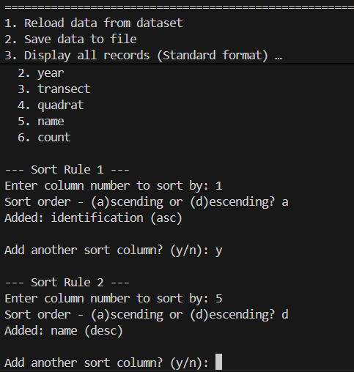
This screenshot shows the process of adding a second sort criterion. After selecting the first column and sort order, the program asks if the user wants to add another column. This demonstrates the multi-level sorting capability where users can specify primary, secondary, and tertiary sort orders.

Screenshot 4: Sort Rules Summary
This screenshot displays the summary of all selected sort rules before executing the sort. It shows each column that will be used for sorting along with its order (ascending or descending), giving users a clear view of the sorting criteria they've specified.

Screenshot 5: Sorted Results Display
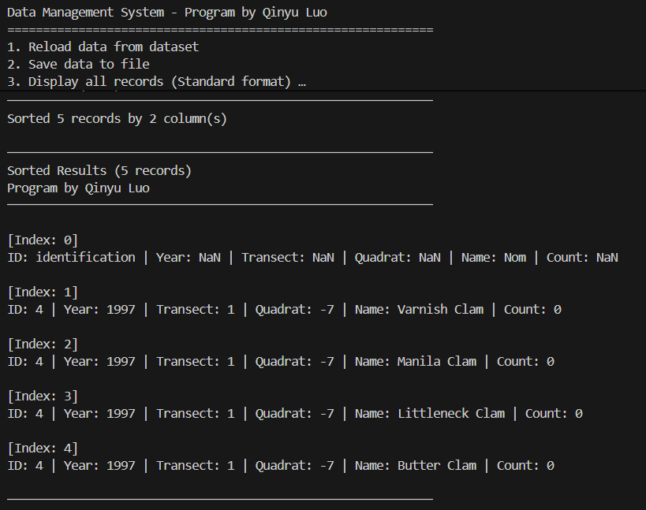
This screenshot shows the sorted results. Records are displayed in the order specified by the sort criteria. The display includes the total number of sorted records and the programmer's name (Qinyu Luo). Each record shows all fields including identification, year, transect, quadrat, name, and count.

Screenshot 6: Multiple Column Sort Example
This screenshot demonstrates a complex sort with three columns: first by year (descending), then by transect (ascending), and finally by count (descending). The results clearly show that records are grouped by year first, then within each year group they are ordered by transect, and within each transect they are ordered by count.

References
[1] Mozilla Developer Network. (n.d.). Array.prototype.sort(). MDN Web Docs. [Online] Available at: https://developer.mozilla.org/en-US/docs/Web/JavaScript/Reference/Global_Objects/Array/sort [Accessed: December 2024]
[2] Mozilla Developer Network. (n.d.). String.prototype.localeCompare(). MDN Web Docs. [Online] Available at: https://developer.mozilla.org/en-US/docs/Web/JavaScript/Reference/Global_Objects/String/localeCompare [Accessed: December 2024]
[3] W3Schools. (n.d.). JavaScript Sorting Arrays. [Online] Available at: https://www.w3schools.com/js/js_array_sort.asp [Accessed: December 2024]
[4] Git. (n.d.). Git Basics - Tagging. git-scm.com. [Online] Available at: https://git-scm.com/book/en/v2/Git-Basics-Tagging [Accessed: December 2024]
[5] Git. (n.d.). Git Branching - Branches in a Nutshell. git-scm.com. [Online] Available at: https://git-scm.com/book/en/v2/Git-Branching-Branches-in-a-Nutshell [Accessed: December 2024]

